**Validation of an Email ID**

**Problem Statement:** You have an array of email IDs of employees. write a program to search the email ID entered by a user. write a program to search a string entered by a user from the array of strings.

**Java-Code**

import java.util.Scanner;

public class EmailSearchProgram {

public static void main(String[] args) {

// Array of email IDs to search

String[] emailArray = {"Sai@gmail.com", "Sarvani@yahoo.com", "SIddiq@hotmail.com", "shiva@apple.com"};

// Scanner for user input

Scanner scanner = new Scanner(System.in);

// Prompt user for input

System.out.println("Array of Email IDs: " + String.join(", ", emailArray));

System.out.print("Enter an email ID to search: ");

String searchEmail = scanner.nextLine();

// Perform the search

boolean found = false;

for (String email : emailArray) {

if (email.equals(searchEmail)) {

found = true;

break;

}

}

// Display result

if (found) {

System.out.println("Email ID found in the array!");

} else {

System.out.println("Email ID not found in the array.");

}

}

}

IDE-Eclipse and Code Execution

1. Create a new class with the name EmailSearchProgram
2. Import java packages which are needed

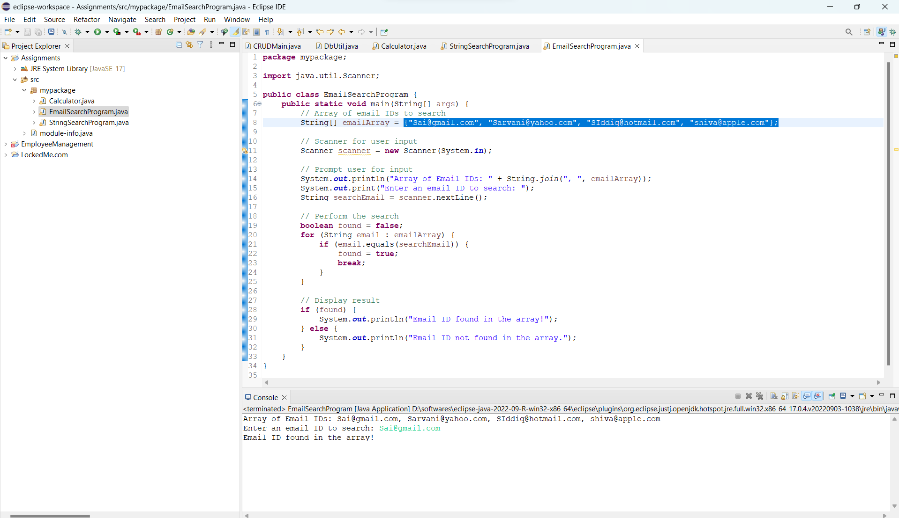

Program Output:

This program uses a simple array of email IDs and prompts the user to enter an email ID for searching. It then iterates through the array using a **for** loop and checks if the entered email ID exists in the array. Compile and run this program to test the email search functionality. You can modify the array or expand the program as needed for your specific requirements.

Pushing Files from local repository to git hub repository

